**Introduction to Computers II - Assignment #8: Polymorphism**

**Tasks**

1. Modify class “GeneralPlayer” and its derived classes
2. Design class “AbstractMonster” and its derived classes

**Inheritance Hierarchy**

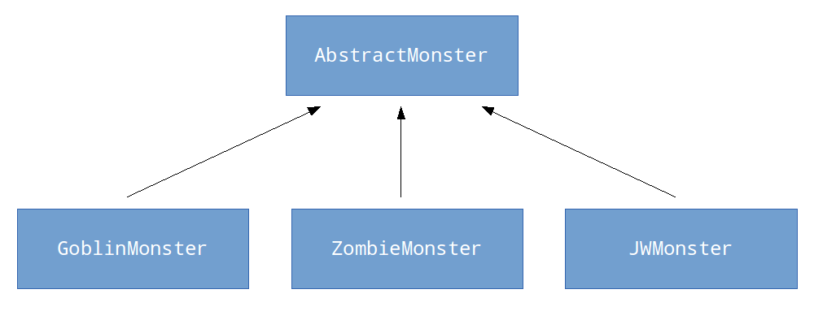

=======================================================================

I. Modify class “GeneralPlayer” and its derived classes

1. Modify “setAttr(int)” and “levelUp(void)” to virtual functions.
2. Add a public “void attackTo(AbstractMonster*)” function to GeneralPlayer (this function is also inherited by its derived classes).

This function does:

* 1. get the defense of AbstractMonster*
  2. calculate actual damage by *(attack of player – damage of monster) +/- 10%*
  3. decrease the HP of the monster
  4. if monster dies, increase the experience of that player

1. Implement void specialSkill() function
   1. Public accessible
   2. Virtual function
   3. heal() in KnightPlayer
   4. pray() in MagicianPlayer
   5. For OrcPlayer and GeneralPlayer, this function does nothing

II. Class “AbstractMonster”

1. public const data members
   1. string name
   2. int attack
   3. int defense
   4. int exp
   5. int max_hp
   6. int max_mp
2. private data members
   1. int hp
   2. int mp
3. static data member
   1. int count // stores the number of alive monsters
4. constructor
   1. AbstractMonster(string, int, int, int, int, int)
5. destructor
   1. ~AbstractMonster()
6. public member functions
   1. void setHP(int)
   2. int getHP() const
   3. void setMP(int)
   4. int getMP() const
7. pure virtual public function
   1. void attack(GeneralPlayer*)

III. Derived classes of “AbstractMonster”

1. Constructors and destructors
2. Please implement a function “void attack_to(GeneralPlayer*)”, it does:

* *normal attack* to a player if that monster is a GoblinMonster
* randomly choose *normal attack* or *super attack*(attack*2 & decrease MP by 10) if that monster is a ZombieMonster
* recover HP by 10% and MP by 5% at the beginning of every turn of monsters. Then randomly choose a *normal attack* or 2\**super attack* if that monster is a JWMonster

IV. Predefined values

|  |  |  |  |
| --- | --- | --- | --- |
|  | GoblinMonster | ZombieMonster | JWMonster |
| name | Goblin | Zombie | JWHuang |
| attack | 60 | 50 | 120 |
| defense | 40 | 65 | 100 |
| exp | 12 | 17 | 42 |
| max_hp | 100 | 150 | 250 |
| max_mp | 50 | 30 | 100 |